Praktikum Arduino Using Ethernet Shield

Octgi Ristya Perdana | 5213100176

Information System | Sepuluh Nopember Institute of Technology

Author Note

Melakukan praktikum tentang penggunaan Ethernet shield pada Arduino, dan bagaimana Arduino dapat di akses oleh device lain yang berada pada satu jaringan dengan Arduino.

# Materi Praktikum

Materi praktikum Arduino Ethernet shield ini yaitu bagaimana Arduino dapat disambungkan dengan Ethernet shield dan apa saja fungsi Ethernet shield yang ada pada Arduino, selain itu juga pada praktikum kali ini dibahas tentang cara pengiriman data yang ada pada Arduino untuk di tampilkan ke dalam web server, dimana Arduino itu sendiri yang akan menjadi web servernya.

Alat yang perlu di persiapkan untuk melakukan praktikum :

1. Arduino.
2. Ethernet shield.
3. Sensor yang ingin di gunakan untuk mengambil data.
4. Laptop.

## Menjadikan Arduino Sebagai Web Server.

Pertama untuk menjadikan Arduino sebagai webserver yaitu dengan cara sebagai berikut :

1. Sambungkan Ethernet shield dengan arduino.
2. Buka Arduino IDE.
3. Pilih code default dari Arduino dimana penggunaan Arduino sebagai Ethernet shield.
4. Jalankan kode pada Arduino.
5. Arduino telah menjadi web server.

## Penggunaan Sensor untuk Pengambilan Data dan Menampilkan Pada Web Server.

Selanjutnya ketika Arduino sudah dapat menjadi web server maka selanjutnya menggunakan sensor untuk mengambil data dan menampilkannya pada web server :

1. Pilih sensor yang akan di gunakan.
2. Persiapkan codingan dari sensor yang digunakan.
3. Tampilkan data tersebut pada web server.

Berikut merupakan contoh code yang di tampilkan dalam web server :

#include <SPI.h>  
#include <Ethernet.h>  
byte mac[] = {   
  0xDE, 0xAD, 0xBE, 0xEF, 0xFE, 0xED };  
IPAddress ip(192,168,1,177);  
EthernetServer server(80);  
  
void setup() {  
  Serial.begin(9600);  
   while (!Serial) {  
    ;   
  }  
  Ethernet.begin(mac, ip);  
  server.begin();  
  Serial.print("server is at ");  
  Serial.println(Ethernet.localIP());  
}  
void loop() {  
  EthernetClient client = server.available();  
  if (client) {  
    Serial.println("new client");  
    // an http request ends with a blank line  
    boolean currentLineIsBlank = true;  
    while (client.connected()) {  
      if (client.available()) {  
        char c = client.read();  
        Serial.write(c);   
               if (c == '\n' && currentLineIsBlank) {  
          client.println("HTTP/1.1 200 OK");  
          client.println("Content-Type: text/html");  
          client.println("Connection: close");    
      client.println("Refresh: 5");    
          client.println();  
          client.println("<!DOCTYPE HTML>");  
          client.println("<html>");  
          // output the value of each analog input pin  
          for (int analogChannel = 0; analogChannel < 6; analogChannel++) {  
            int sensorReading = analogRead(analogChannel);  
            client.print("analog input ");  
            client.print(analogChannel);  
            client.print(" is ");  
            client.print(sensorReading);  
            client.println("<br />");         
          }  
          client.println("</html>");  
          break;  
        }  
        if (c == '\n') {  
          // you're starting a new line  
          currentLineIsBlank = true;  
        }   
        else if (c != '\r') {  
          // you've gotten a character on the current line  
          currentLineIsBlank = false;  
        }  
      }  
    }  
    // give the web browser time to receive the data  
    delay(1);  
    // close the connection:  
    client.stop();  
    Serial.println("client disonnected");  
  }  
}

          for (int analogChannel = 0; analogChannel < 6; analogChannel++) {  
            int sensorReading = analogRead(analogChannel);  
            client.print("analog input ");  
            client.print(analogChannel);  
            client.print(" is ");  
            client.print(sensorReading);  
            client.println("<br />");         
          }  
          client.println("</html>");  
          break;  
        }  
        if (c == '\n') {   
          currentLineIsBlank = true;  
        }   
        else if (c != '\r') {   
          currentLineIsBlank = false;  
        }  
      }  
    }  
    // give the web browser time to receive the data  
    delay(1);   
    client.stop();  
    Serial.println("client disonnected");  
  }  
}

# Dokumentasi

Berikut merupakan dokumentasi ketika Praktikum :

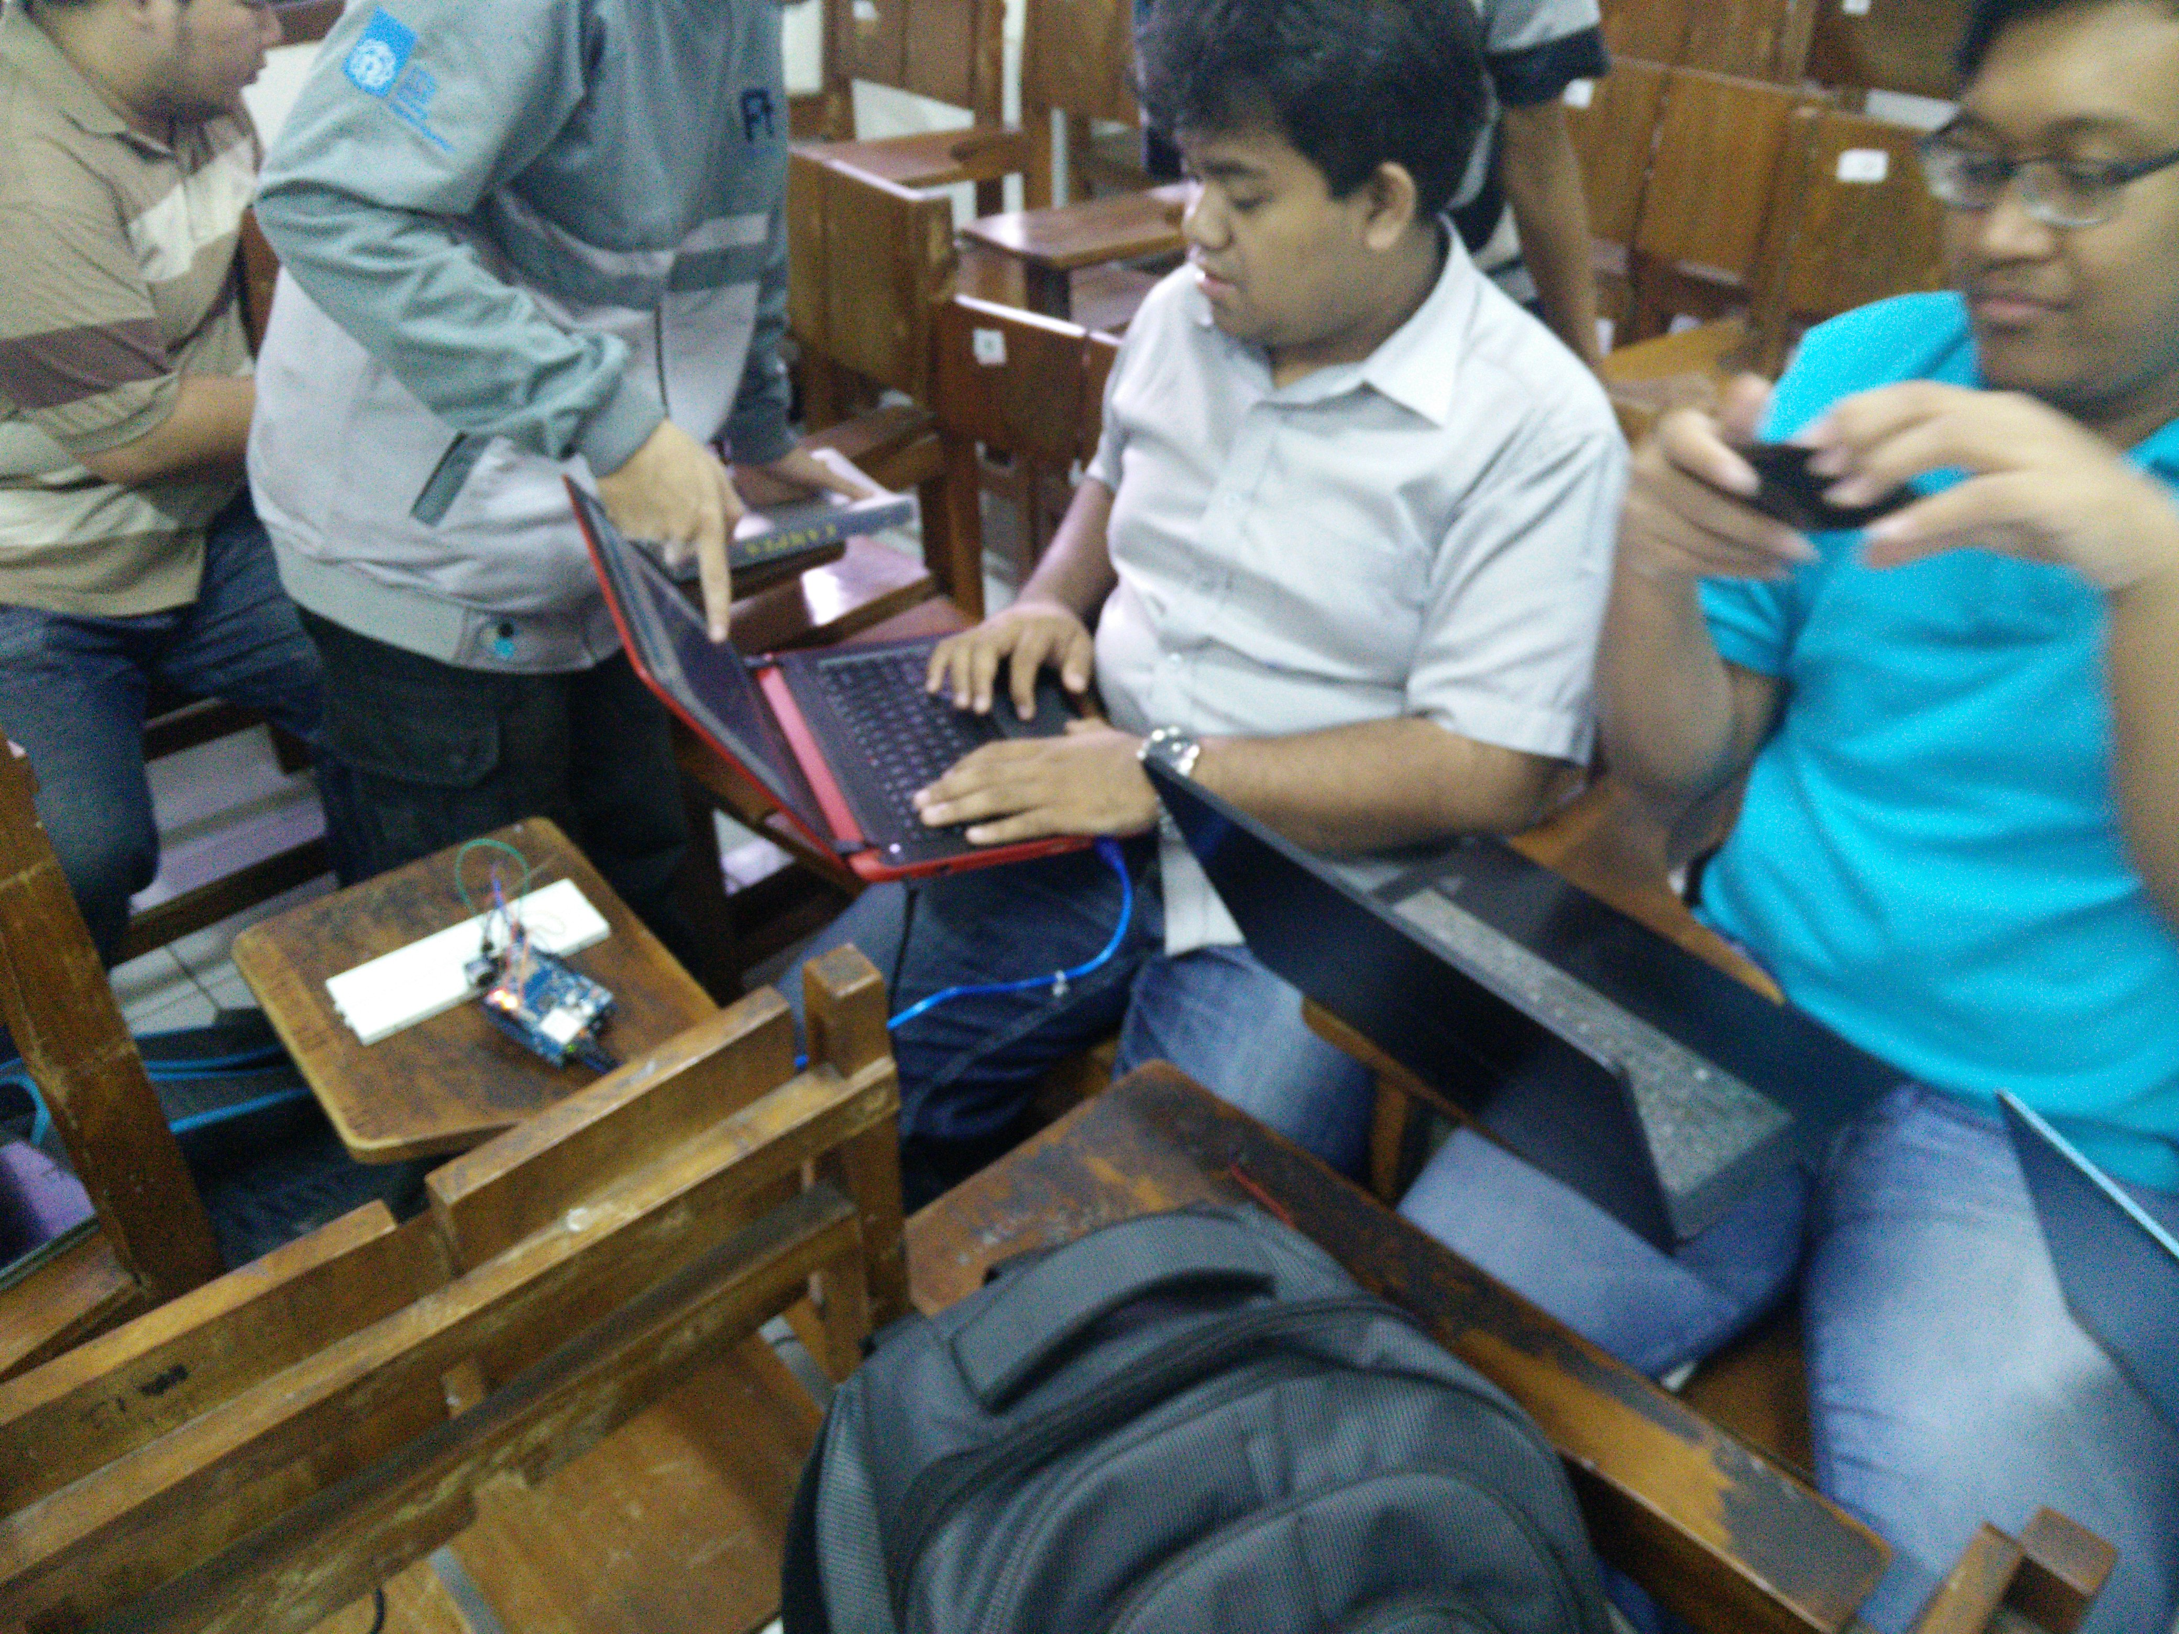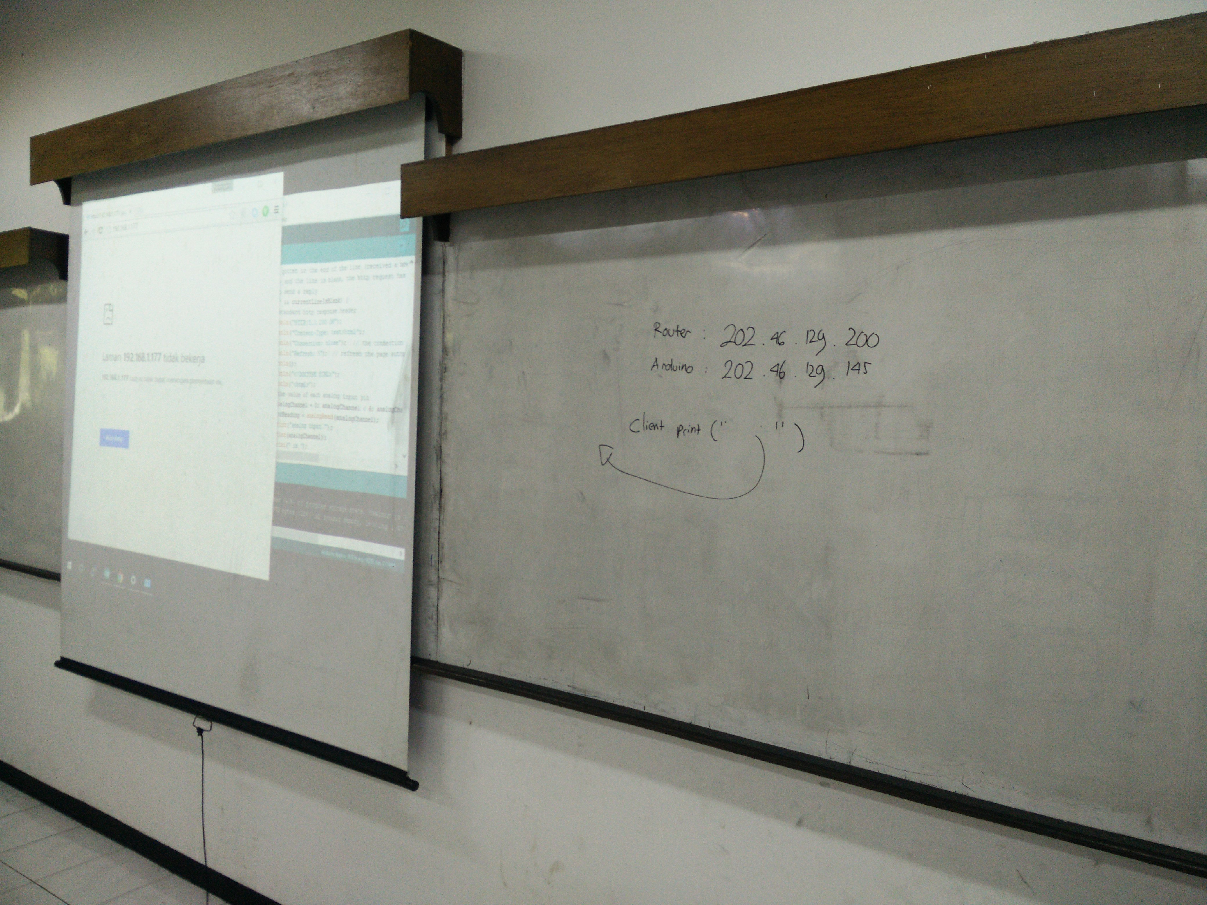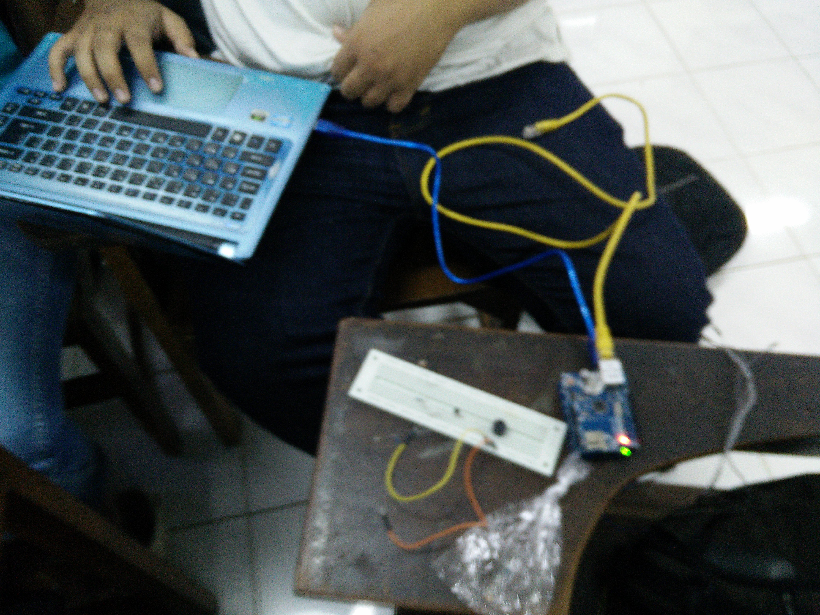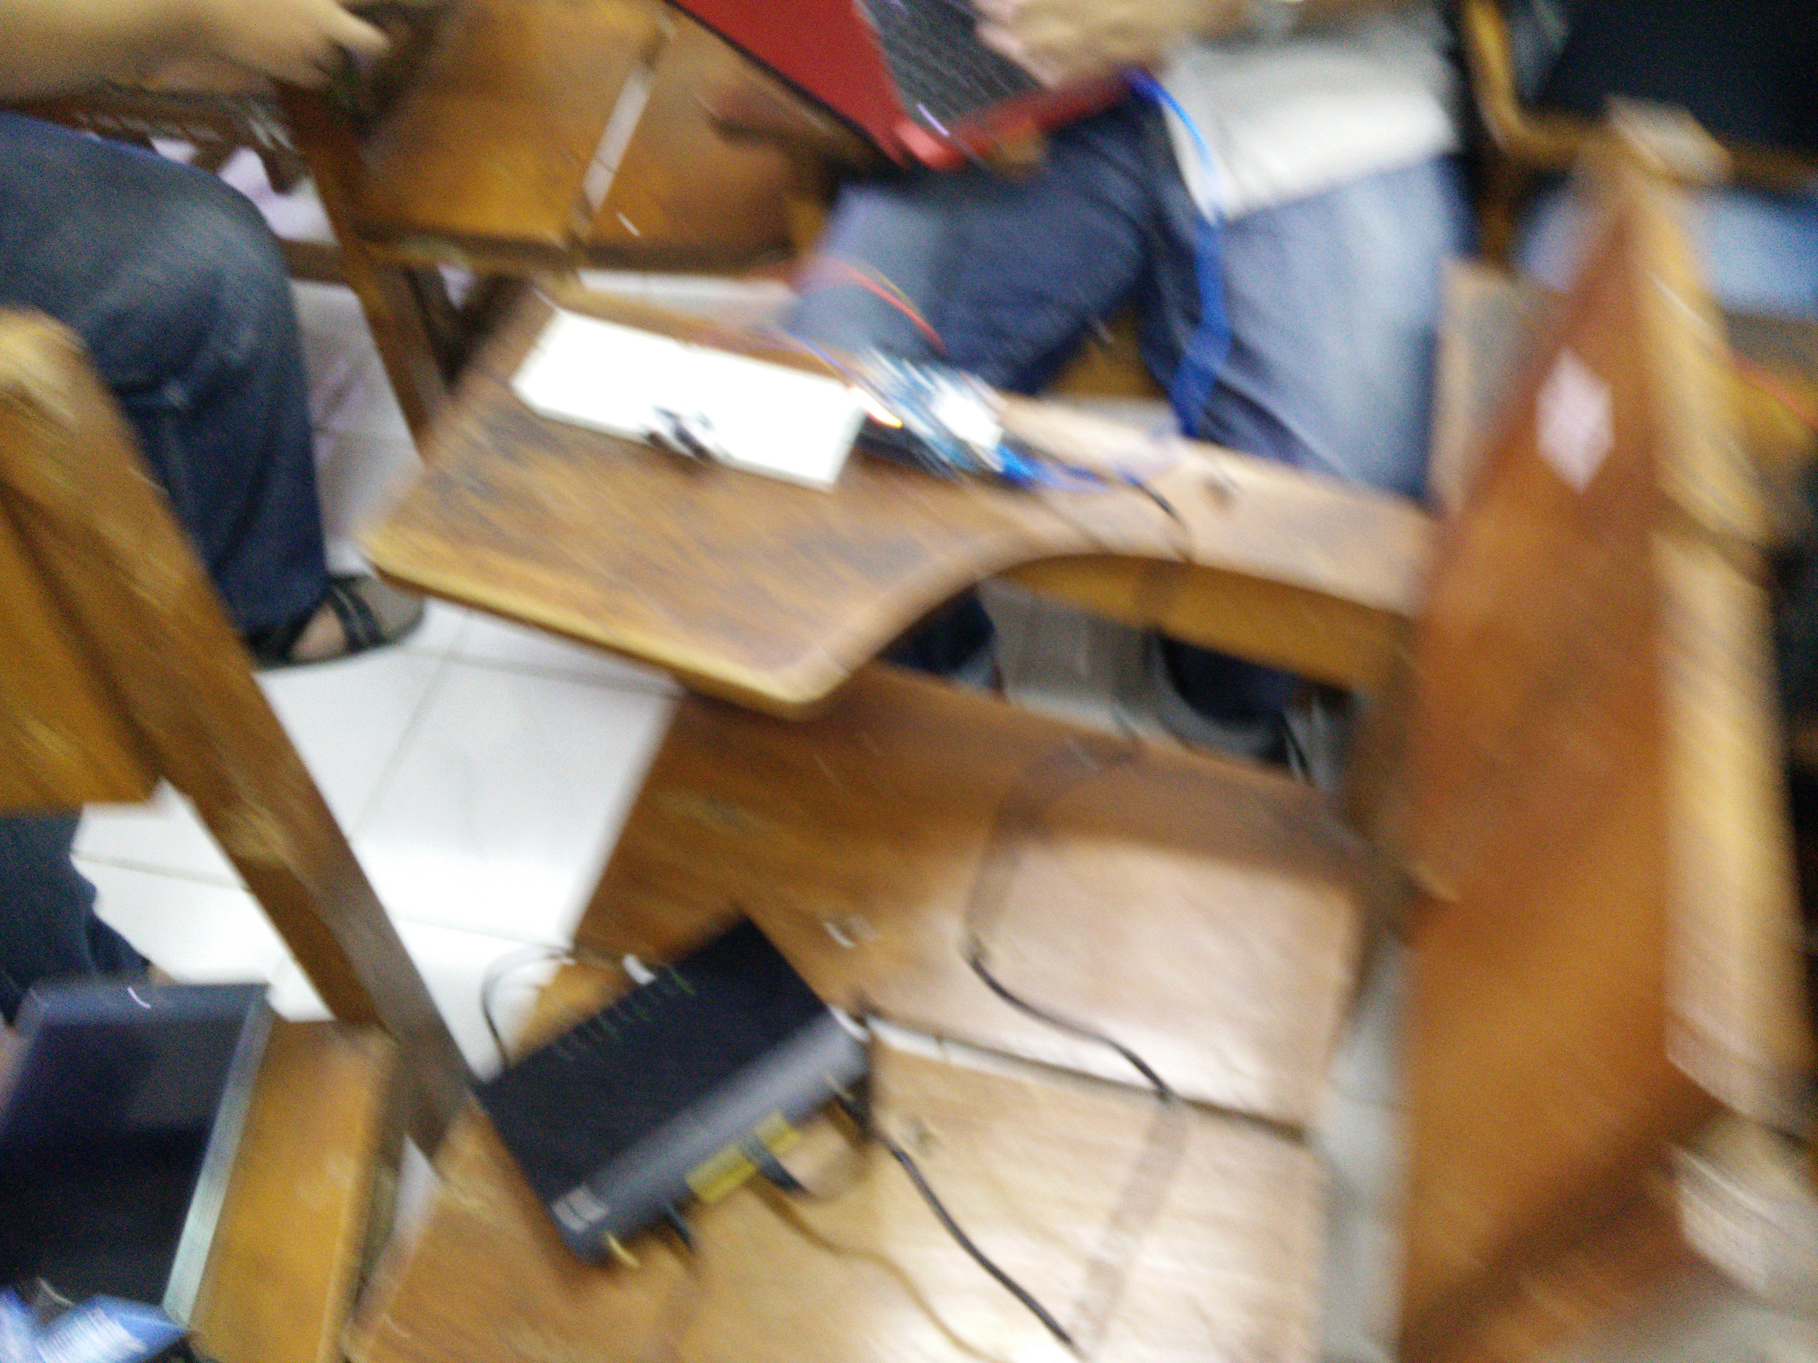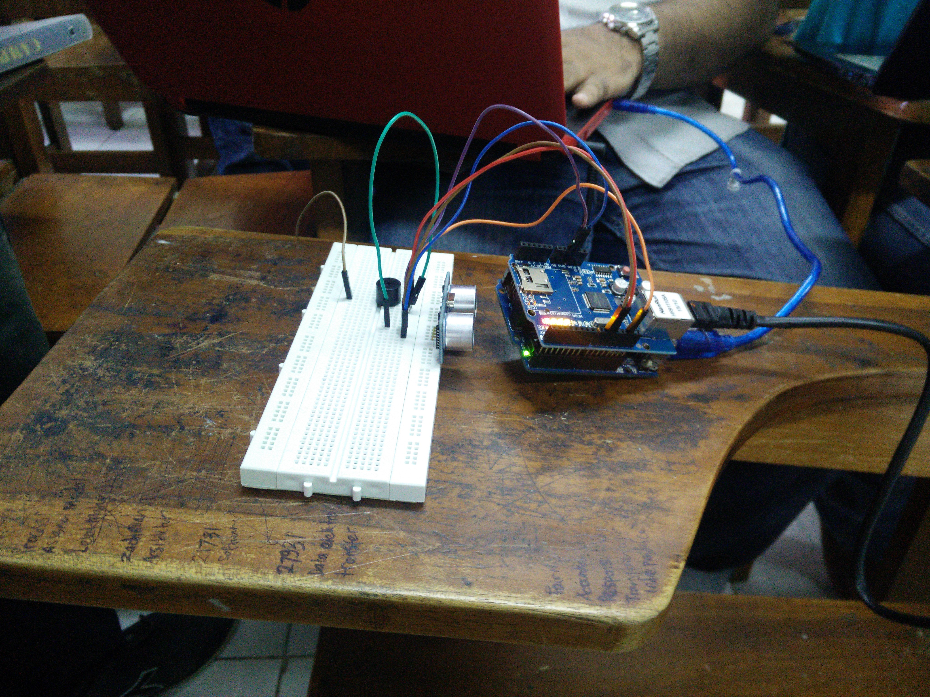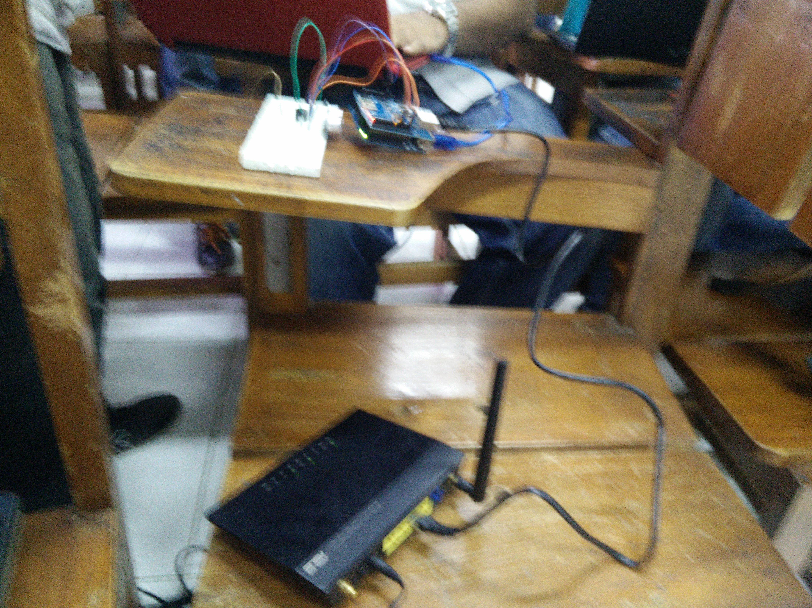

Praktikum Arduino Using Ethernet Shield

[The body of your paper uses a half-inch first line indent and is double-spaced. APA style provides for up to five heading levels, shown in the paragraphs that follow. Note that the word Introduction should not be used as an initial heading, as it’s assumed that your paper begins with an introduction.]

# [Heading 1]

[The first two heading levels get their own paragraph, as shown here. Headings 3, 4, and 5 are run-in headings used at the beginning of the paragraph.]

## [Heading 2]1

[To add a table of contents (TOC), apply the appropriate heading style to just the heading text at the start of a paragraph and it will show up in your TOC. To do this, select the text for your heading. Then, on the Home tab, in the Styles gallery, click the style you need.]

[Heading 3]. [Include a period at the end of a run-in heading. Note that you can include consecutive paragraphs with their own headings, where appropriate.]

[Heading 4]. [When using headings, don’t skip levels. If you need a heading 3, 4, or 5 with no text following it before the next heading, just add a period at the end of the heading and then start a new paragraph for the subheading and its text.] (Last Name, Year)

[Heading 5]. [Like all sections of your paper, references start on their own page. The references page that follows is created using the Citations & Bibliography feature, available on the References tab. This feature includes a style option that formats your references for APA 6th Edition. You can also use this feature to add in-text citations that are linked to your source, such as those shown at the end of this paragraph and the preceding paragraph. To customize a citation, right-click it and then click Edit Citation.] (Last Name, Year)

References

Last Name, F. M. (Year). Article Title. *Journal Title*, Pages From - To.

Last Name, F. M. (Year). *Book Title.* City Name: Publisher Name.

Footnotes

1[Add footnotes, if any, on their own page following references. For APA formatting requirements, it’s easy to just type your own footnote references and notes. To format a footnote reference, select the number and then, on the Home tab, in the Styles gallery, click Footnote Reference. The body of a footnote, such as this example, uses the Normal text style. (Note: If you delete this sample footnote, don’t forget to delete its in-text reference as well. That’s at the end of the sample Heading 2 paragraph on the first page of body content in this template.)]

Tables

Table 1

[Table Title]

|  |  |  |  |  |
| --- | --- | --- | --- | --- |
| Column Head | Column Head | Column Head | Column Head | Column Head |
| Row Head | 123 | 123 | 123 | 123 |
| Row Head | 456 | 456 | 456 | 456 |
| Row Head | 789 | 789 | 789 | 789 |
| Row Head | 123 | 123 | 123 | 123 |
| Row Head | 456 | 456 | 456 | 456 |
| Row Head | 789 | 789 | 789 | 789 |

Note: [Place all tables for your paper in a tables section, following references (and, if applicable, footnotes). Start a new page for each table, include a table number and table title for each, as shown on this page. All explanatory text appears in a table note that follows the table, such as this one. Use the Table/Figure style, available on the Home tab, in the Styles gallery, to get the spacing between table and note. Tables in APA format can use single or 1.5 line spacing. Include a heading for every row and column, even if the content seems obvious. A default table style has been setup for this template that fits APA guidelines. To insert a table, on the Insert tab, click Table.]

Figures

Figure 1. [Include all figures in their own section, following references (and footnotes and tables, if applicable). Include a numbered caption for each figure. Use the Table/Figure style for easy spacing between figure and caption.]

For more information about all elements of APA formatting, please consult the APA Style Manual, 6th Edition.